File security in Laptops
Using Mutual authentication

Sachin kumar.S
Department of Computer Science and Engineering
College of Engineering,Guindy
Chennai,India
Sachinsundar1159@gmail.com
Sandhya.A.K, Priyavarshini.M
Department of Computer Science and Engineering
College of Engineering,Guindy
Chennai,India

Abstract—There are possibilities that most important details in files may be hacked and can be used without proper authentication from the file owner. This may lead to malicious attack of files from the system and there are chances that they can be used inappropriately. Thus our project deals with implementation of security for files in pc using an application that is present in both the personal computer of the user and the user’s android mobile and hence enhancing security by establishing communication between the computer and the mobile phone. Thus the file systems and folders can be accessed only if both the gateways present in android mobile and the laptop provides authentication.

Keywords— QR-code, Hiding, Authentication
.

Introduction
The main purpose of the project is to enhance file security in pc/laptop. If a laptop is stolen then the level of security should be such that the files and folders are not accessed by the hackers in any case. This is because every laptop is tied to a unique mobile for accessing the files and folders and hence the files cannot be accessed without the android phone. This application, which is both a blend of windows application and android application implements multiple levels of security providing at most safe ensuring of users files.

Overview
The project File-security in personal computer deals with securing all the files in one’s personal computer with the help of his / her android mobile phone. Thus the file security is implemented as an application that has its working in both user’s android mobile and personal computer or laptop. This enables different levels of security and at most basic level ensures that the files that are stored in this application is accessed only when the android application allows access to enter the application. The application splits the passcode into two halves and stores it in the database. The first half of the passcode is entered in the android application and validated against the database. This paves the way to scan the QR code that is generated in the windows application. Once the QR code is scanned it is cross checked and validated. For a particular user his Laptop’s MAC address is stored as a string to be generated as a QR code. Then the second half of the passcode is validated and this gives the way for the user to access his valuable files.

Organisation of chapters
This project is done in two parts as is mentioned before. The two parts are organized in various different chapters that is correspondingly in the windows side and the android mobile side. So the whole project is explained in detail based on the following organization of chapters.
Chapter 2- Requirement specifications
Chapter 3-Technology that is used in the project
Chapter 4-System design of the project
Chapter5-Implementation of the projects and its test results
Chapter6-Conclusion and future scope

Literature Survey
BLUETOOTH ENABLED MOBILE PHONE REMOTE CONTROL FOR PC
This work confers an application which makes possible to use Bluetooth enabled mobile phone to remote control home appliances that are connected to the PC as well as other computer applications. The datasets used are Bluetooth, mobile phones, home networking, PAN, wireless networks, J2ME, Java. In this the time for searching the device can be eradicated if the same PC is used again and again by storing the serial port service URL and using it directly to open connection. Also by this the Bluetooth enabled mobile devices can be used to control home appliances as well.

POCKETDROID-A PC REMOTE CONTROL
The user can connect to any computer having Server Application running on it. It is basically an Android based Mobile Application for controlling a Target PC. User can have full access of the Target PC, provided its IP address is known. The datasets here are Android, IP address, JAVA, Linux OS, pervasive computing, remote desktop, remote visualization, smart phone, wireless handheld devices. It involves running of basic Linux or Windows Commands via android application. It provides a mechanism for graphically interacting with files and folders of target PC..
SESSION KEY EXCHANGE AND MUTUAL AUTHENTICATION SCHEME BETWEEN MOBILE MACHINES IN WLAN BASED AD HOC NETWORKS
The main idea of this paper is that non-interactive session key exchange uses the mobile machine's ID and mutual authentication without communication with an authentication server whenever a data transmission occurs between the mobile machines.
TECHNOLOGY

C# PROGRAMMING LANGUAGE
C# is a multi-paradigm programming language encompassing strong typing, imperative, declarative, functional, generic, object oriented(class based), and component oriented programming disciplines. It was developed by Microsoft within .NET initiative and later approved as a standard ECMA( ECMA-334) and ISO (ISO/IEC 23270:2006$). C# is one of the programming languages designed for the Common Language Infrastructure. C# is a modern, general-purpose, object-oriented programming language developed by Microsoft and approved by European Computer Manufacturers Association (ECMA) and International Standards Organization (ISO).C# was developed by Anders Hejlsberg and his team during the development of .Net Framework .C# is designed for Common Language Infrastructure (CLI), which consists of the executable code and runtime environment that allows use of various high-level languages on different computer platforms and architectures.

THE .NET FRAMEWORK
The .Net framework is a revolutionary platform that helps you to write the following types of applications: Windows applications, Web applications, Web services. The .Net framework applications are multi-platform applications. The framework has been designed in such a way that it can be used from any of the following languages: C#, C++, Visual Basic, Jscript, COBOL, etc. All these languages can access the framework as well as communicate with each other. The .Net framework consists of an enormous library of codes used by the client languages such as C#.

ANDROID CODE (JAVA)
Android software development is the process by which new applications are created for the Android operating system. Applications are usually developed in Java programming language using the Android software development kit (SDK), but other development environments are also available

1.ANDROID SDK

The Android software development kit (SDK) includes a comprehensive set of development tools. These include a debugger, libraries, a handset emulator based on QEMU, documentation, sample code, and tutorials. Currently supported development platforms include computers running Linux (any modern desktop Linux distribution), Mac OS X 10.5.8 or later, and Windows 7 or later. As of March 2015, the SDK is not available on Android itself, but software development is possible by using specialized Android applications

2. ANDROID DEBUG BRIDGE
The Android Debug Bridge (ADB) is a toolkit included in the Android SDK package. It consists of both client and server-side programs that communicate with one another. The ADB is typically accessed through the command-line interface, although numerous graphical user interfaces exist to control ADB.

Overall system design
- 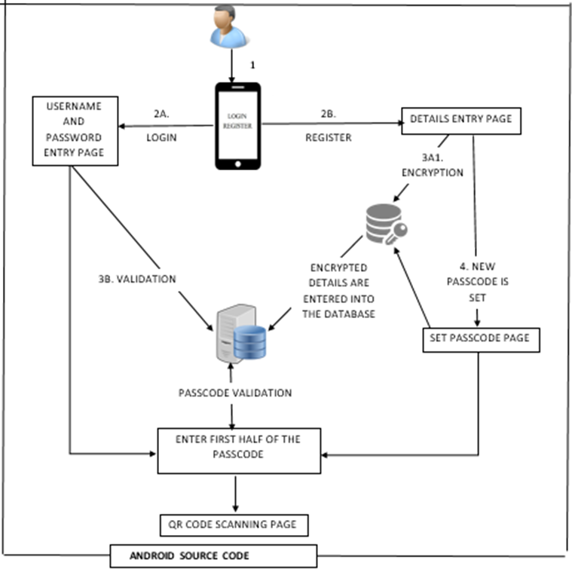
Anroid side
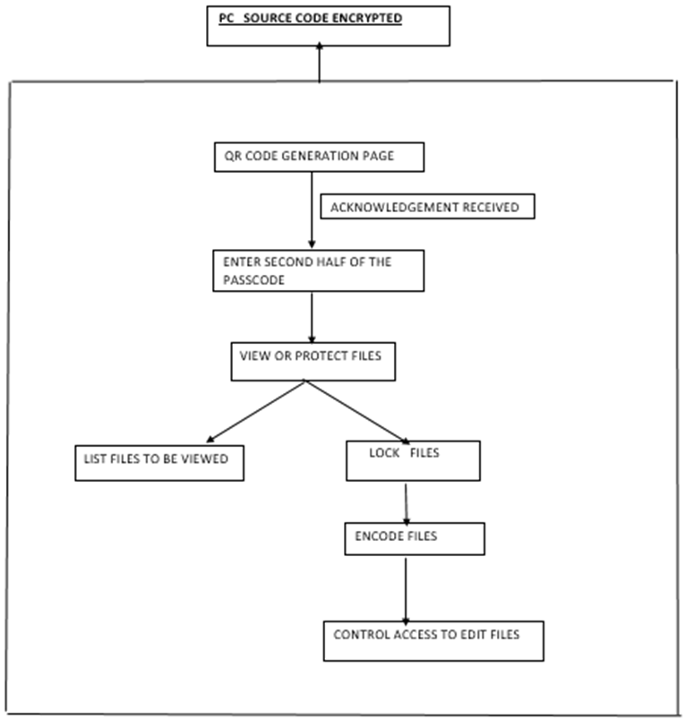
- Windows side
RESULTS
The end result of file security system is that the user can secure any file in his / her laptop in any folder according to his / her wish thus incorporating multiple levels of security so that it is very difficult for the hackers even to trace the location of the files. Thus this keeps the user’s files very secure.
ANALYSIS
The analysis is that once a file is placed within a folder in this application the folder is locked and then even the user can access the file using his smart phone by carrying out the procedure from the start. So accessing a file in the Laptop becomes a level of difficulty for laptop hackers because every laptop is tied to an unique mobile number and every laptop ( identified by the MAC address ) is tied to a phone nu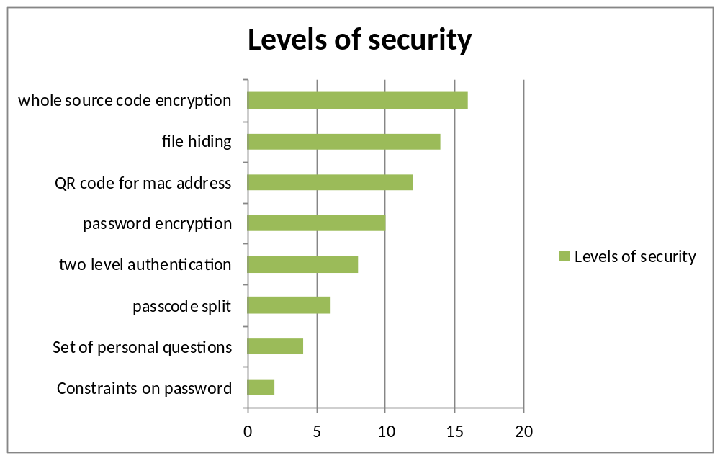Fig 3.Result

Conclusion and Future work
Thus this system provides multiple levels of security for protecting the files and folders in the personal computer by mutual authentication by the android application and the windows application. Hence even if the PC goes into unauthorized person and even they manage to log into the windows account they may not be able to find the files and folders that are protected by this application. The only way to view those files and folders is by using this application. Even if they manage to find the location of the files, the contents are encrypted that makes it difficult to understand the contents of the file.

Our Future work is to enhance the security features, the full code can be encrypted, both android and windows, so that changes in the functionalities of the application can be prevented even if the source code is visible. Further protection can be provided preventing the deletion of the protected files and folders

Acknowledgment
The authors would like to thank the anonymous referees for their invaluable insights..

References

- http://www.techrepublic.com/blog/microsoft-office/prevent-users-from-changing-data-by-using-access-form-control-properties/
- http://www.techrepublic.com/blog/microsoft-office/prevent-users-from-changing-data-by-using-access-form-control-properties/
- https://technet.microsoft.com/en-us/library/ff936144.aspx

